BT – 307

Lab – 07

**1) Name -**  Milind Lakhwani **2) Roll No. –** 200106046

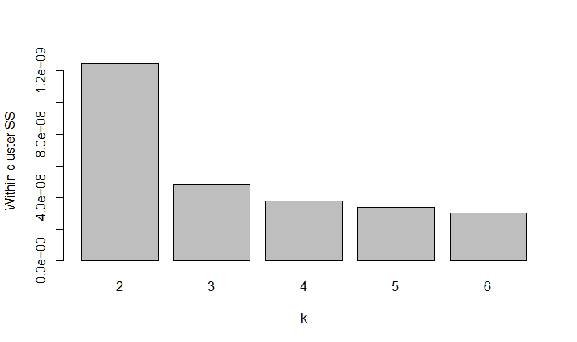**2)**

**3)** From the above graph it can be observed that there is a significant change in WCSS values when number of clusters is changed to 3, and after that for k = 4 WCSS value is still reduced but not much. So 3 and 4 appears to be the reasonable choice.

Now when k = 4, in FL2.H vs FL3.H plot

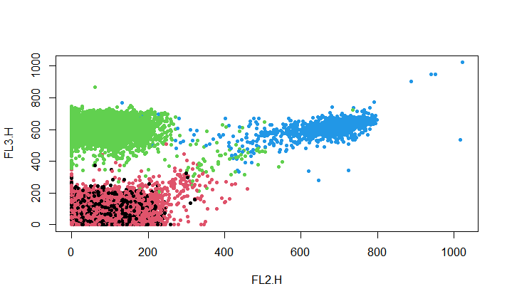

It can clearly be observed that algorithm is over clustering. So we reject k = 4

For final clustering **k = 3** is chosen.

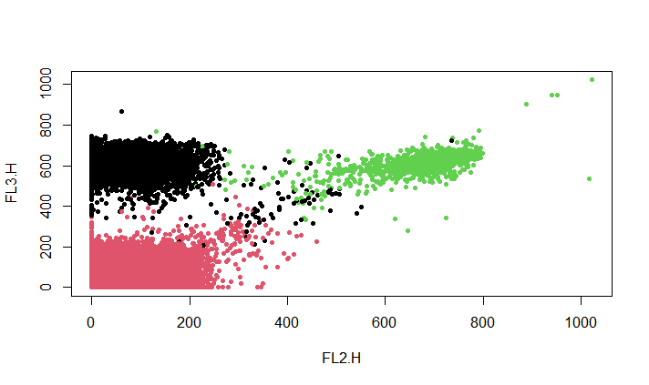**4)** 